Secondary Reference Weight (E2)
# Source: AI Source: Provided by: [Data Path: Persons Table -> ID Column: 1, Name_En Column: Motasem Essam] -> From: [ChatGPT] on [7/17/2026]
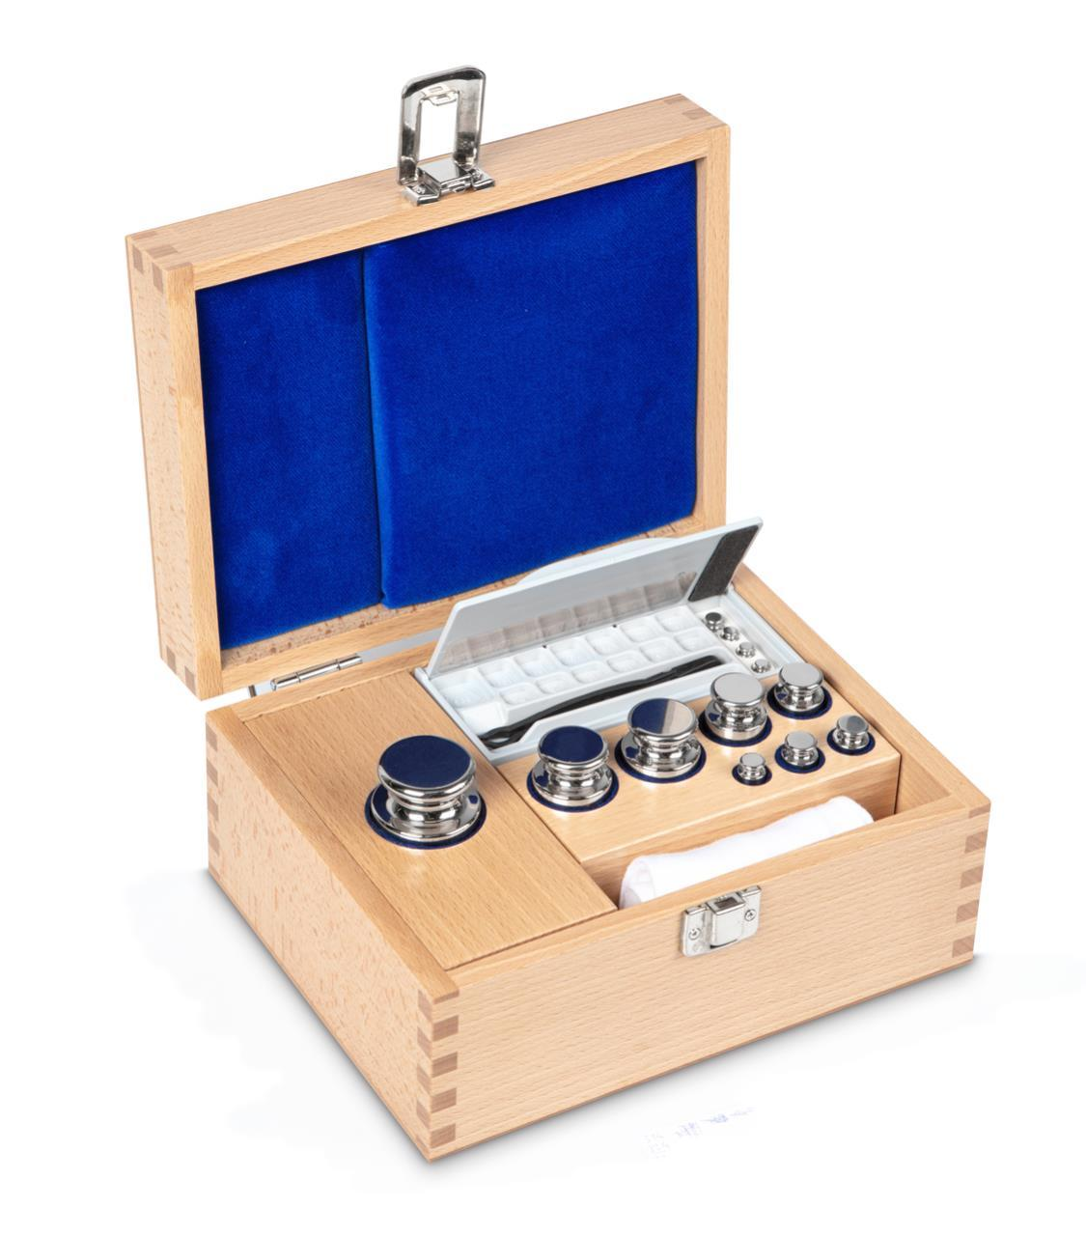
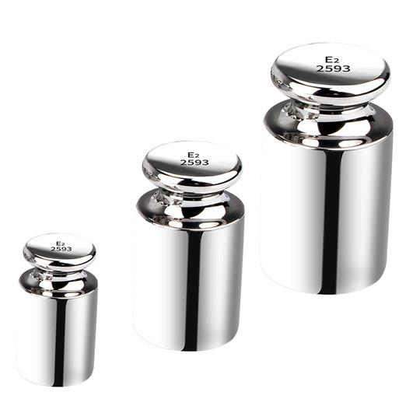
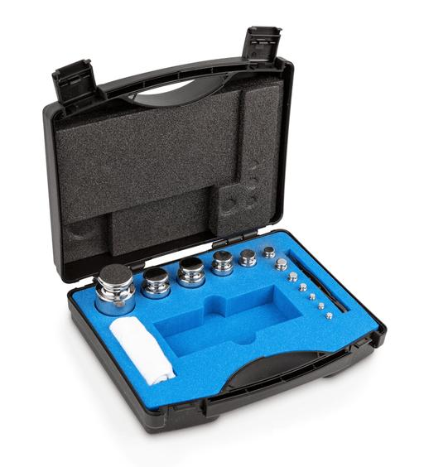
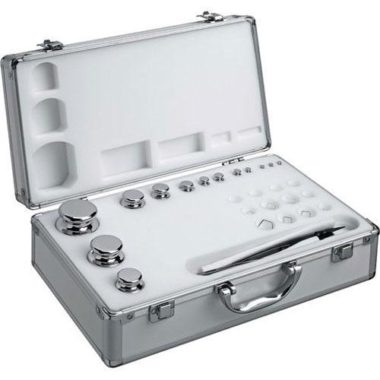
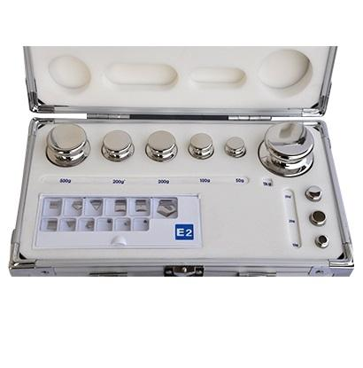
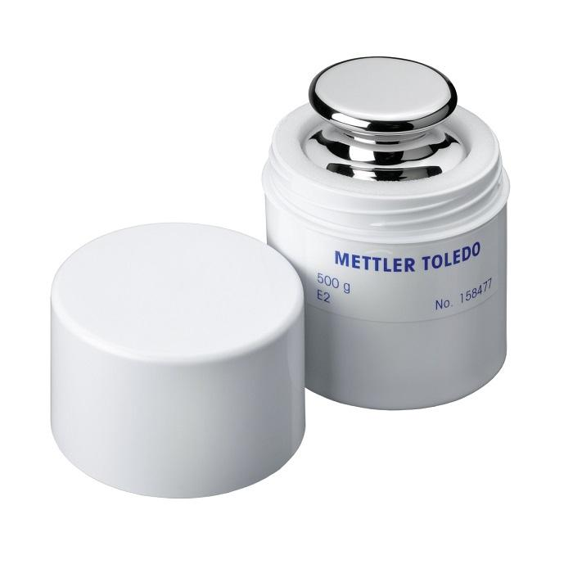
A Secondary Reference Weight (E2) is a high-precision calibration weight that is calibrated against a Primary Reference Weight (E1) and is used to calibrate working standards, analytical balances, and lower-class calibration weights. It provides an essential link in the mass calibration hierarchy, ensuring traceability to the International System of Units (SI).
E2 weights are commonly used in accredited calibration laboratories, pharmaceutical industries, analytical chemistry laboratories, research institutions, and quality assurance laboratories.

Definition
# Source: AI Source: Provided by: [Data Path: Persons Table -> ID Column: 1, Name_En Column: Motasem Essam] -> From: [ChatGPT] on [7/17/2026]
A Secondary Reference Weight (E2) is a precision calibration weight manufactured according to the OIML R111 E2 accuracy class and calibrated against an E1 primary reference weight.

Purpose
# Source: AI Source: Provided by: [Data Path: Persons Table -> ID Column: 1, Name_En Column: Motasem Essam] -> From: [ChatGPT] on [7/17/2026]
E2 reference weights are used to:
- Calibrate F1 and lower-class calibration weights.
- Verify analytical balances.
- Support accredited laboratory calibration.
- Maintain SI traceability.
- Perform high-precision mass comparisons.
- Support pharmaceutical and scientific measurements.

Principle of Operation
# Source: AI Source: Provided by: [Data Path: Persons Table -> ID Column: 1, Name_En Column: Motasem Essam] -> From: [ChatGPT] on [7/17/2026]
An E2 weight provides a certified reference mass.
The balance or lower-class calibration weight is compared against the E2 reference using a high-precision balance or mass comparator.

Main Components
# Source: AI Source: Provided by: [Data Path: Persons Table -> ID Column: 1, Name_En Column: Motasem Essam] -> From: [ChatGPT] on [7/17/2026]


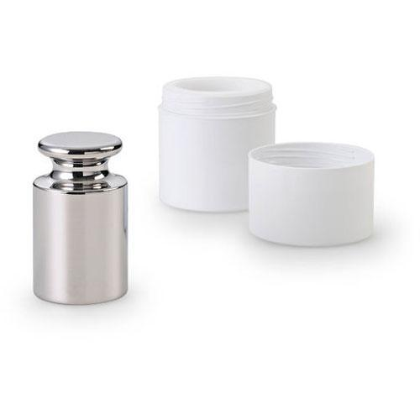
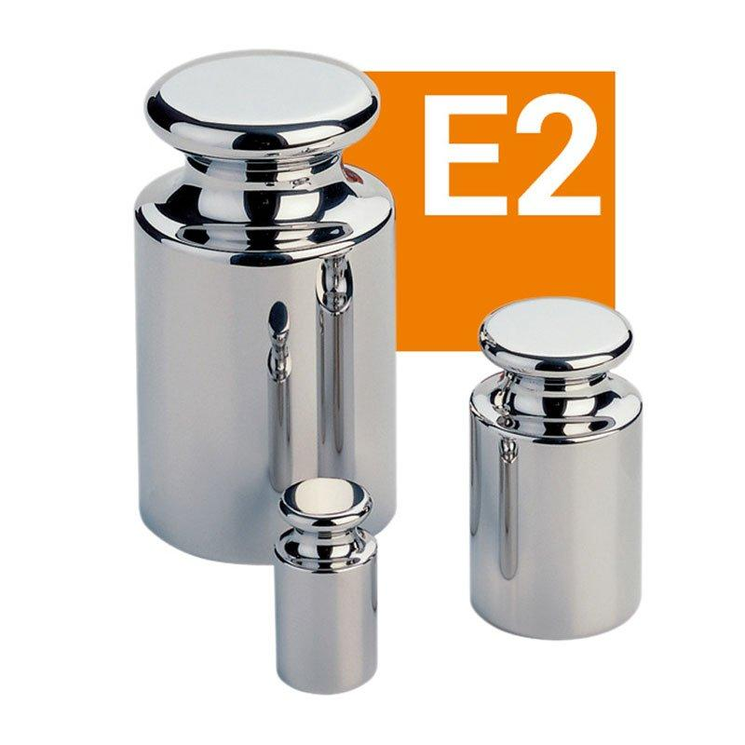
A typical E2 reference weight consists of:
- Non-magnetic stainless-steel body
- Mirror-polished corrosion-resistant surface
- Identification marking
- Protective storage case
- Accredited calibration certificate

Types of E2 Reference Weights

1. Individual E2 Weights
# Source: AI Source: Provided by: [Data Path: Persons Table -> ID Column: 1, Name_En Column: Motasem Essam] -> From: [ChatGPT] on [7/17/2026]
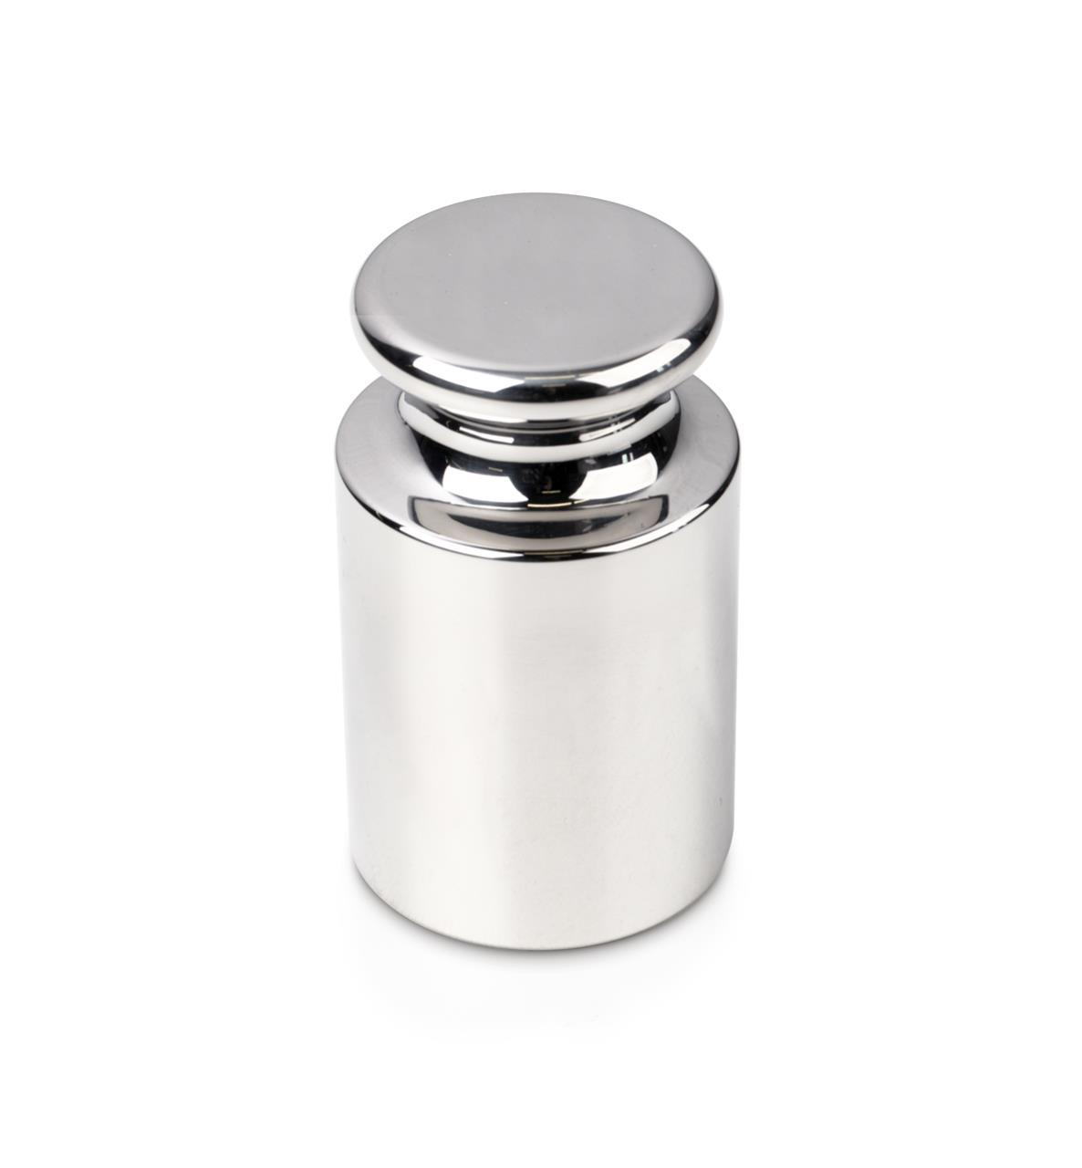

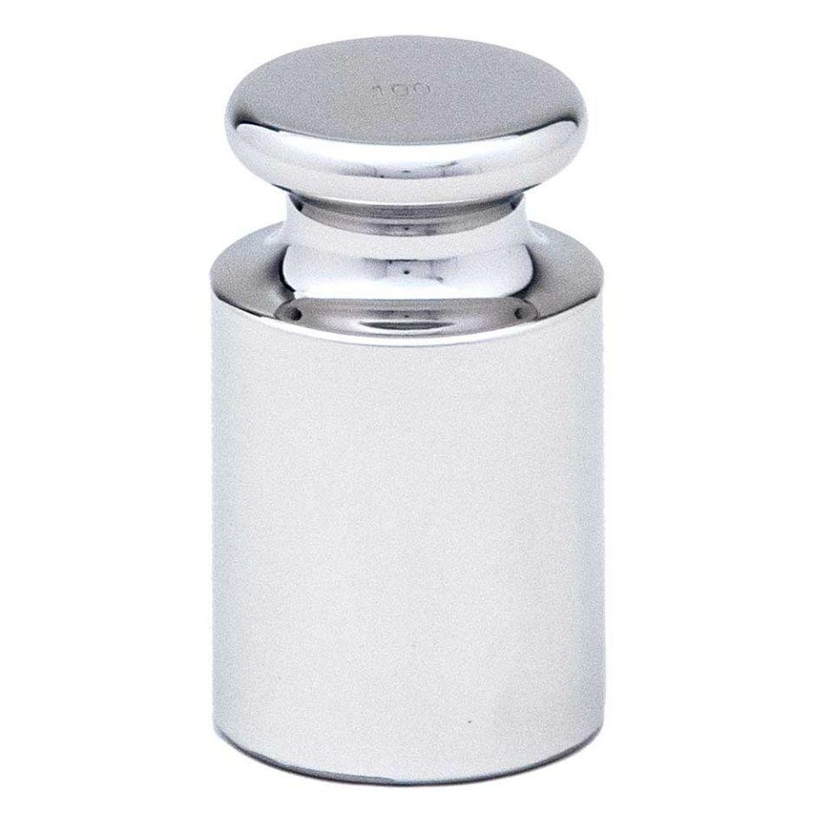

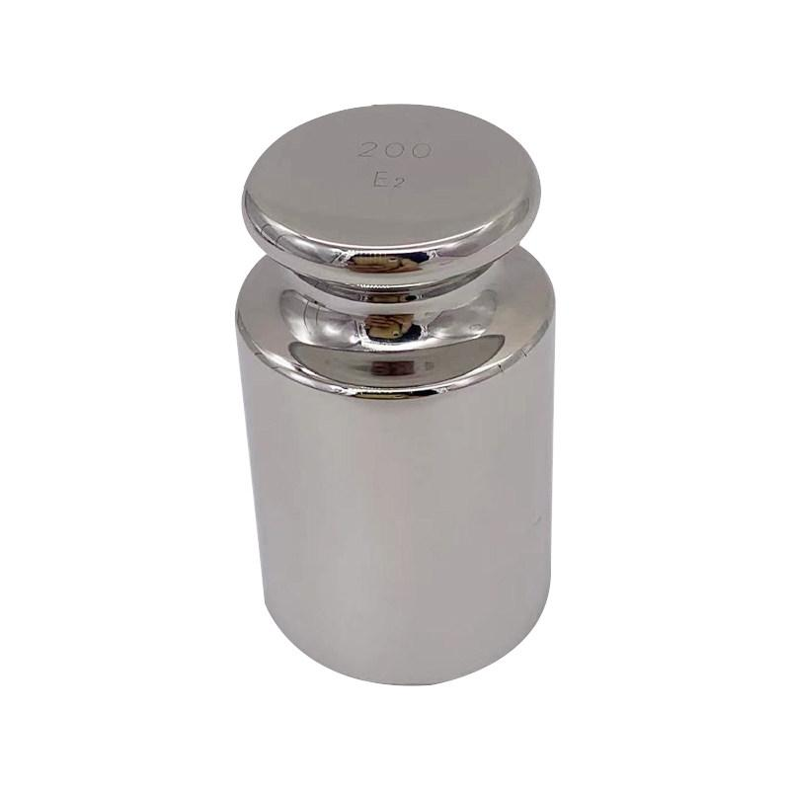
Description
Single certified E2 reference weights used for specific calibration requirements.
Applications
- Analytical balance calibration
- Laboratory verification

2. E2 Weight Sets
# Source: AI Source: Provided by: [Data Path: Persons Table -> ID Column: 1, Name_En Column: Motasem Essam] -> From: [ChatGPT] on [7/17/2026]
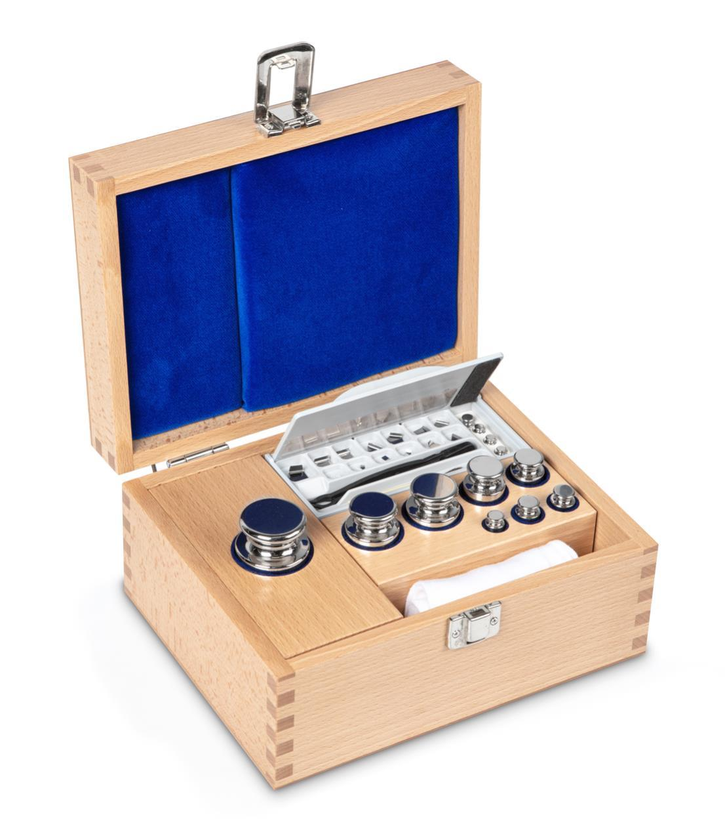
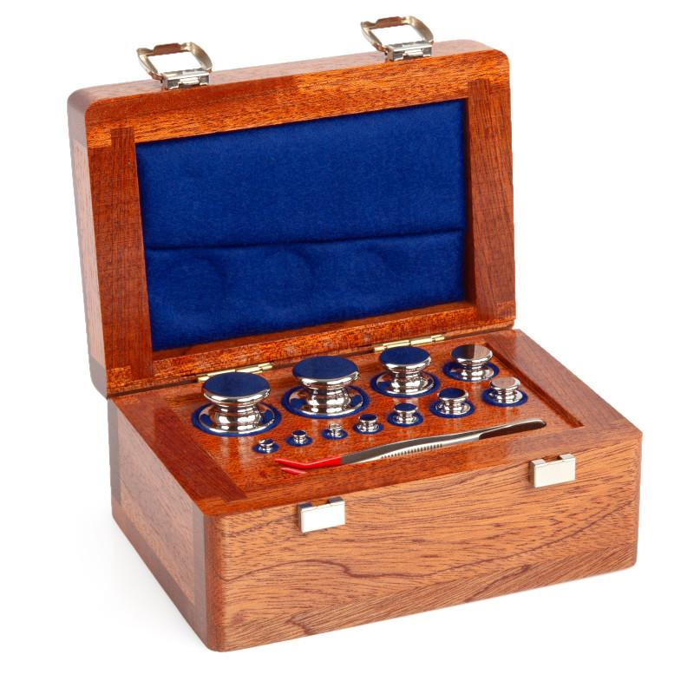
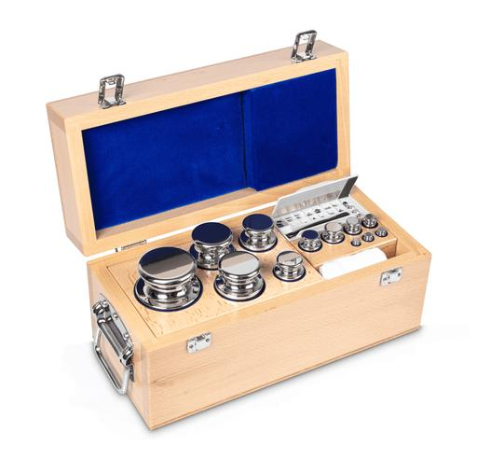
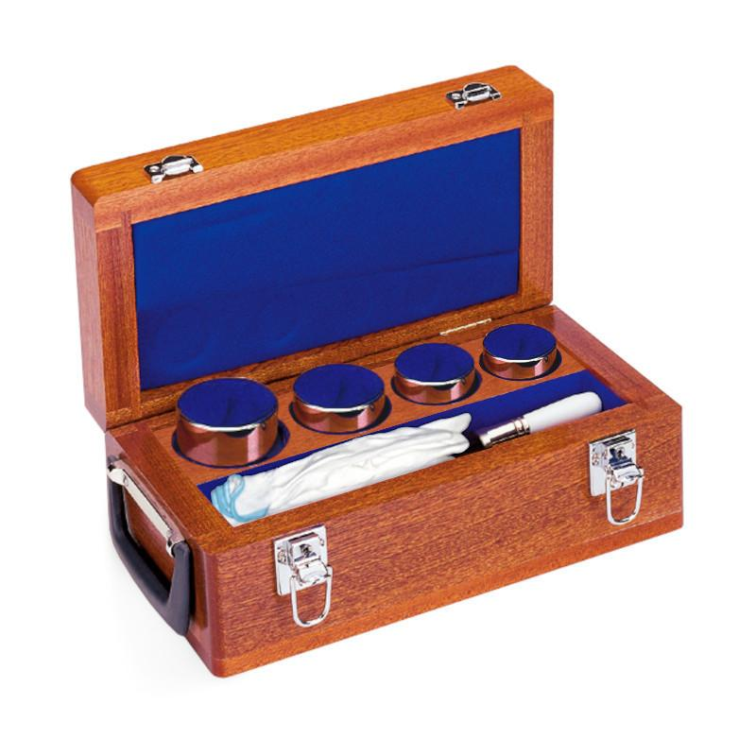
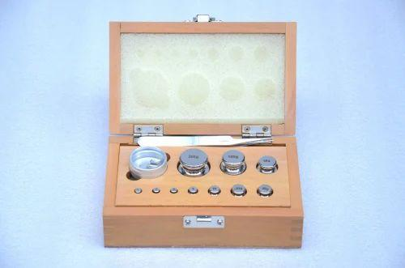
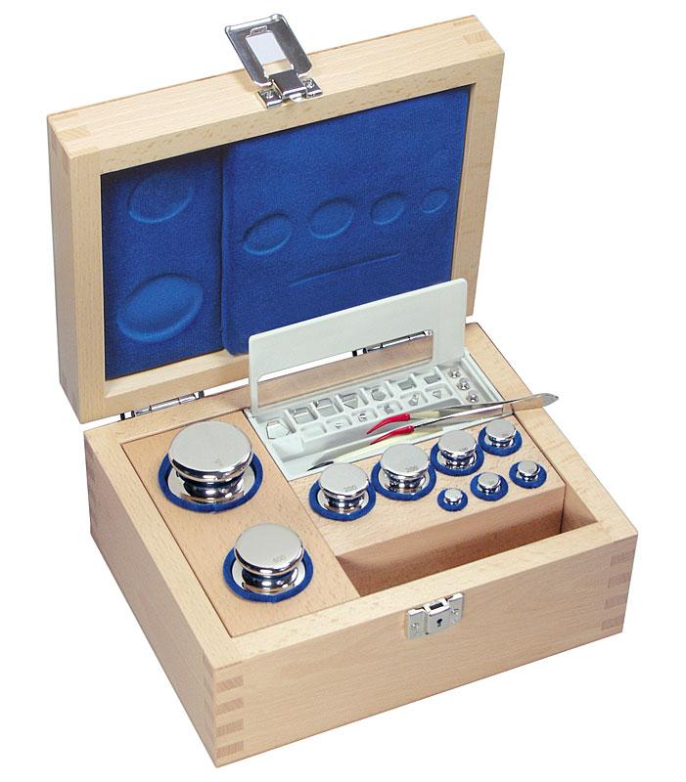
Description
Complete sets containing multiple standard masses for calibration over a wide range.
Applications
- Calibration laboratories
- Research laboratories
- Pharmaceutical industries

3. Cylindrical (Knob) E2 Weights
# Source: AI Source: Provided by: [Data Path: Persons Table -> ID Column: 1, Name_En Column: Motasem Essam] -> From: [ChatGPT] on [7/17/2026]


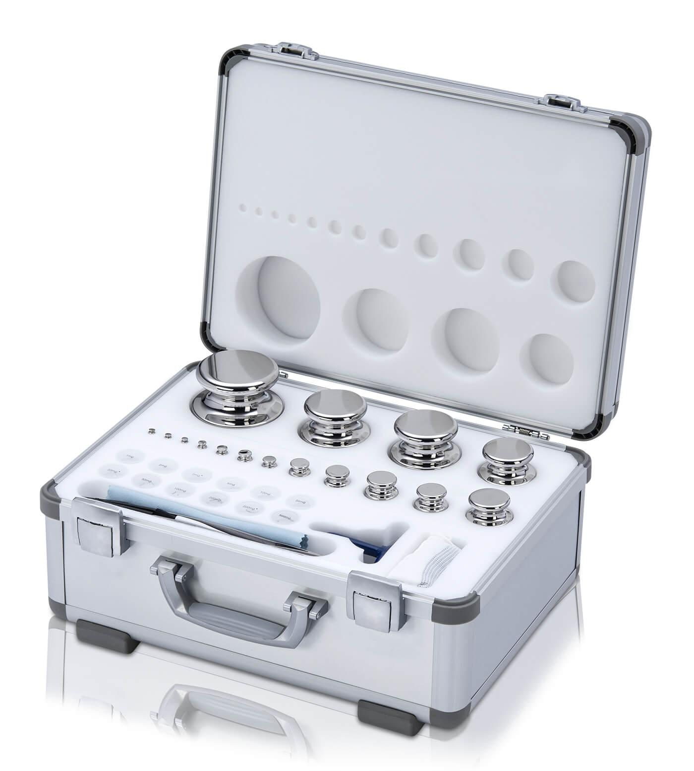
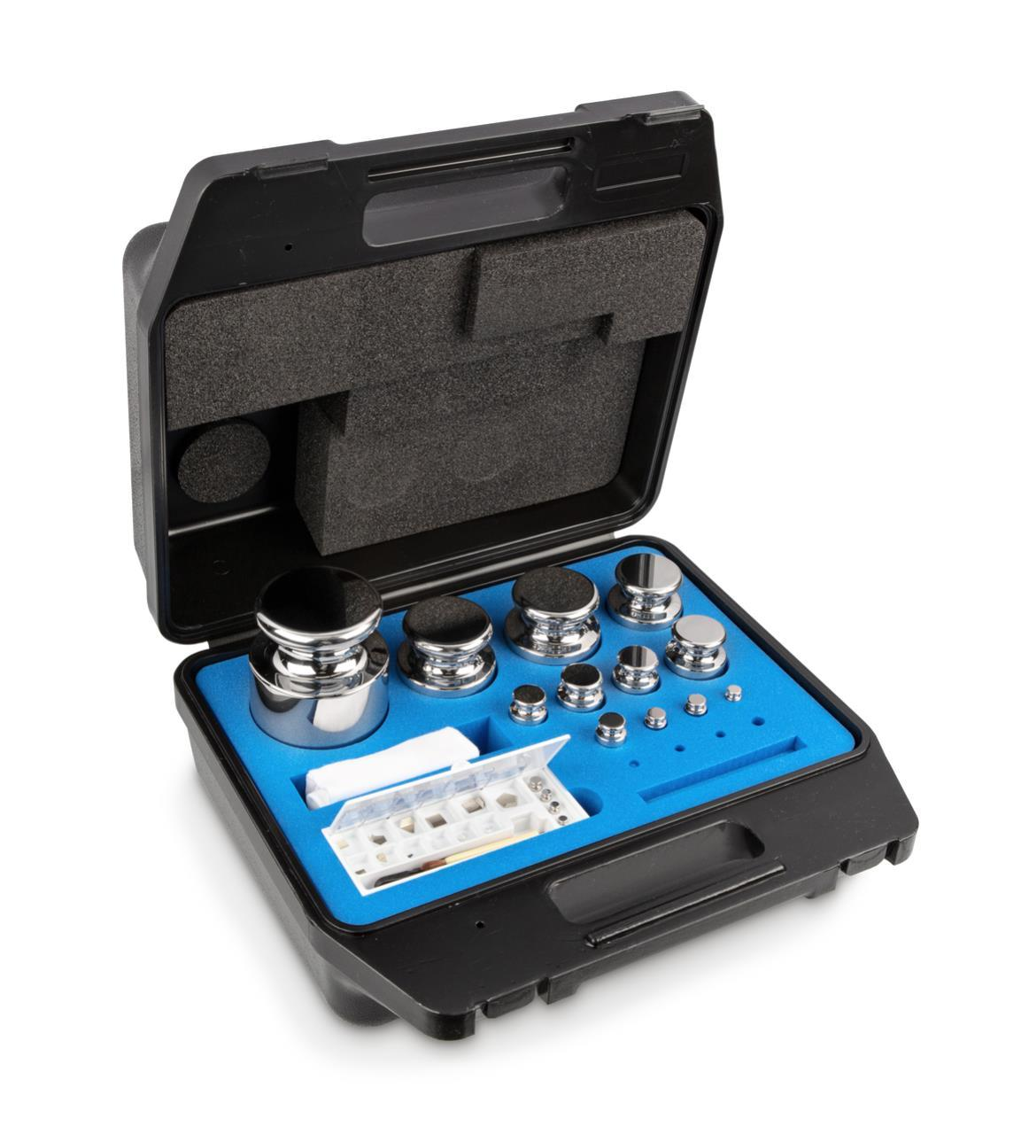
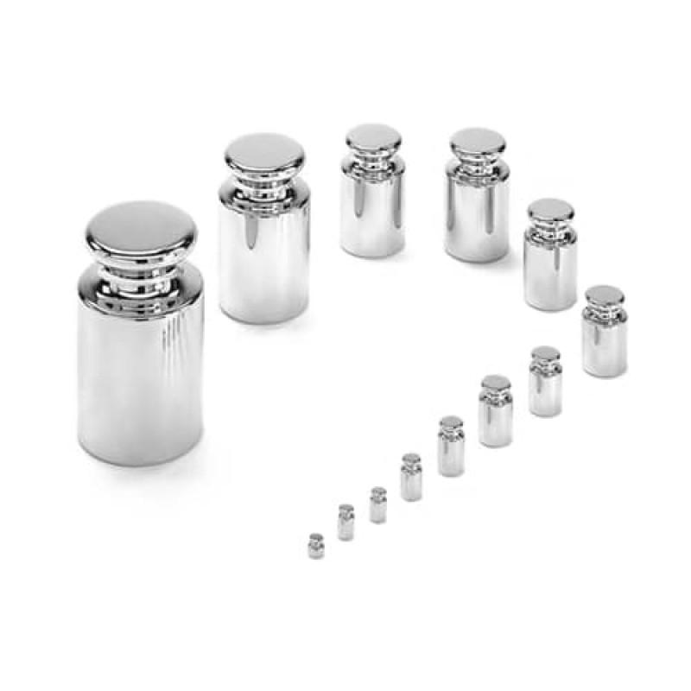
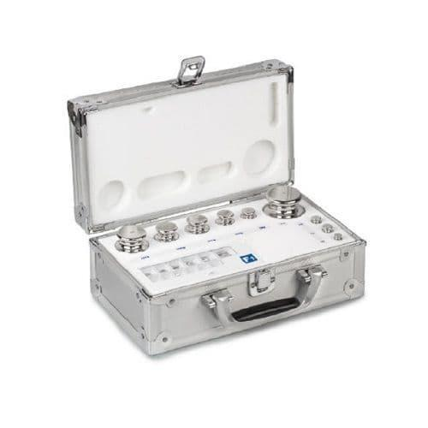
Description
Knob-style cylindrical weights designed for convenient handling of gram and kilogram masses.
Applications
- Precision laboratory calibration
- Accredited calibration laboratories

4. Flat E2 Weights
# Source: AI Source: Provided by: [Data Path: Persons Table -> ID Column: 1, Name_En Column: Motasem Essam] -> From: [ChatGPT] on [7/17/2026]
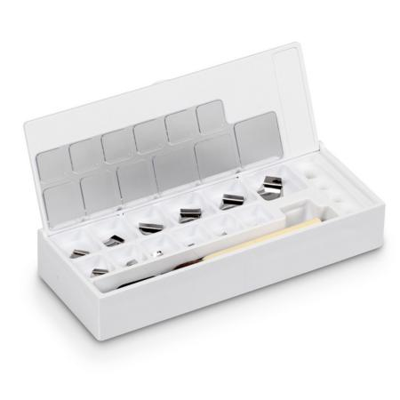
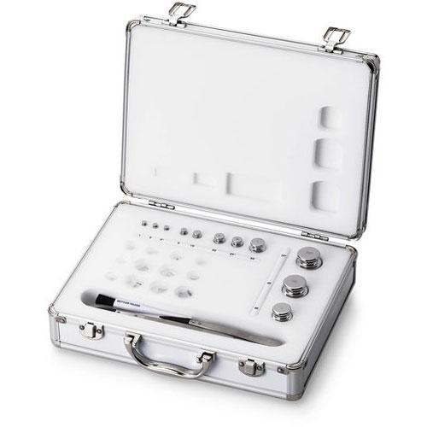
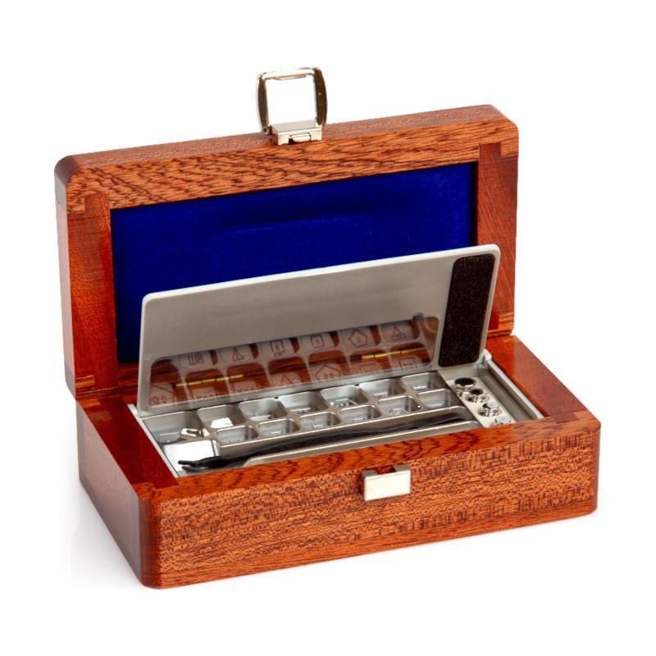
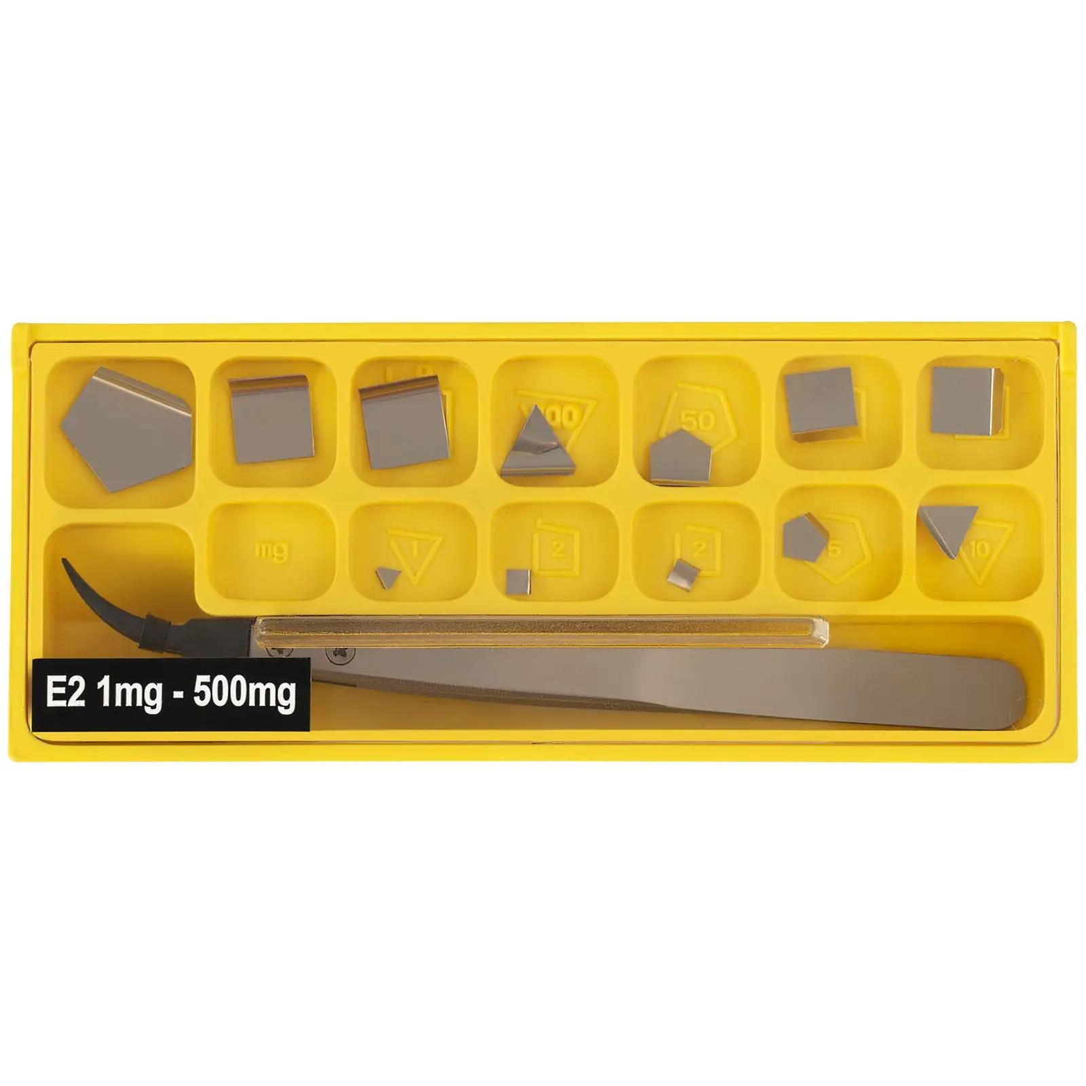
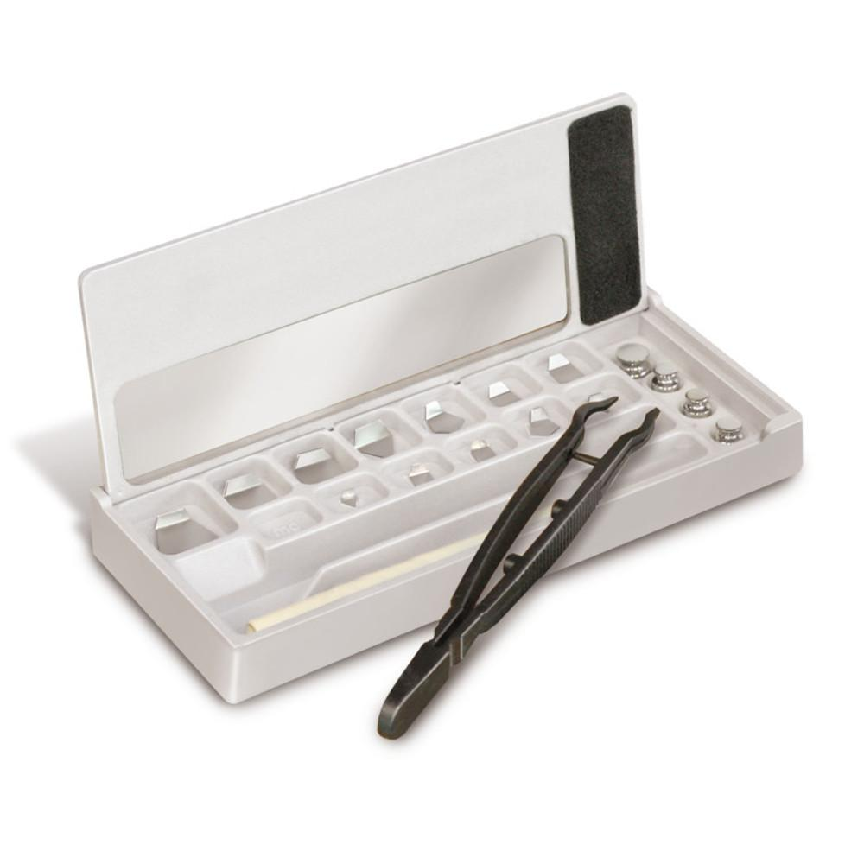
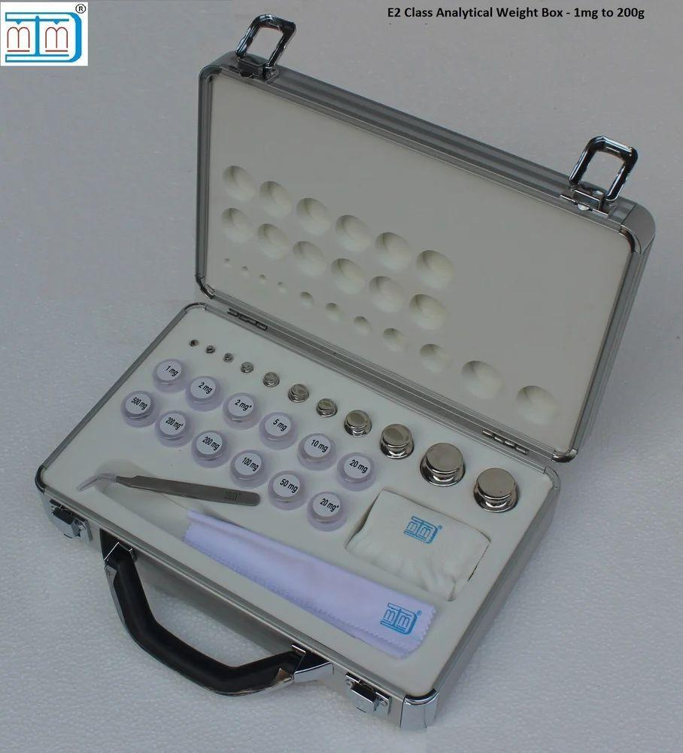
Description
Thin precision weights used for milligram-level calibration.
Applications
- Analytical balances
- Microbalances
- Pharmaceutical laboratories

Materials
# Source: AI Source: Provided by: [Data Path: Persons Table -> ID Column: 1, Name_En Column: Motasem Essam] -> From: [ChatGPT] on [7/17/2026]
E2 weights are typically manufactured from:
- Non-magnetic stainless steel
- Austenitic stainless steel
- Highly stable corrosion-resistant alloys

Measuring Units
# Source: AI Source: Provided by: [Data Path: Persons Table -> ID Column: 1, Name_En Column: Motasem Essam] -> From: [ChatGPT] on [7/17/2026]
E2 weights are manufactured in:
- Milligram (mg)
- Gram (g)
- Kilogram (kg)

Measuring Range
# Source: AI Source: Provided by: [Data Path: Persons Table -> ID Column: 1, Name_En Column: Motasem Essam] -> From: [ChatGPT] on [7/17/2026]
E2 weights are available in standardized nominal masses.
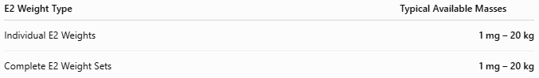
E2 Weight Type | Typical Available Masses
Individual E2 Weights | 1 mg – 20 kg
Complete E2 Weight Sets | 1 mg – 20 kg

Resolution
# Source: AI Source: Provided by: [Data Path: Persons Table -> ID Column: 1, Name_En Column: Motasem Essam] -> From: [ChatGPT] on [7/17/2026]
E2 weights do not perform measurements, therefore they do not have a measurement resolution.
Instead, they are manufactured in precisely defined nominal mass increments.
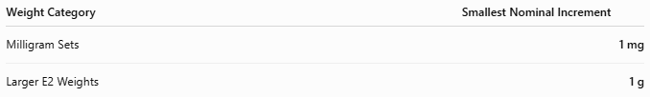
Weight Category | Smallest Nominal Increment
Milligram Sets | 1 mg
Larger E2 Weights | 1 g

Accuracy
# Source: AI Source: Provided by: [Data Path: Persons Table -> ID Column: 1, Name_En Column: Motasem Essam] -> From: [ChatGPT] on [7/17/2026]
The OIML E2 class provides very high precision and is intended for calibrating F1 and lower-class weights and verifying analytical balances.
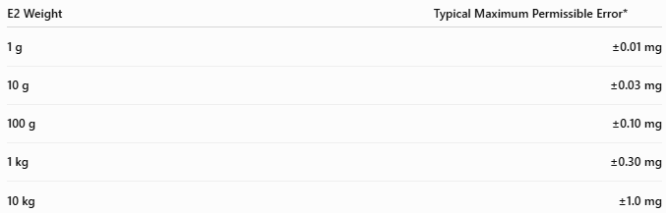
E2 Weight | Typical Maximum Permissible Error*
1 g | ±0.01 mg
10 g | ±0.03 mg
100 g | ±0.10 mg
1 kg | ±0.30 mg
10 kg | ±1.0 mg
*Maximum permissible errors are specified by OIML R111 and increase with nominal mass.
Notes
- E2 weights are calibrated against E1 primary reference weights.
- They provide excellent precision but are slightly less accurate than E1 standards.
- E2 weights are commonly used for the calibration of analytical balances with readability down to 0.1 mg or 0.01 mg, depending on the balance specification.
- Proper handling and environmental control are essential to preserve their accuracy.

How to Use E2 Reference Weights
# Source: AI Source: Provided by: [Data Path: Persons Table -> ID Column: 1, Name_En Column: Motasem Essam] -> From: [ChatGPT] on [7/17/2026]
- Ensure the balance is clean and stabilized.
- Handle weights using gloves or forceps.
- Place the E2 weight gently on the balance.
- Compare the displayed value with the certified mass.
- Record any deviation and recalibrate if necessary.

Applications
# Source: AI Source: Provided by: [Data Path: Persons Table -> ID Column: 1, Name_En Column: Motasem Essam] -> From: [ChatGPT] on [7/17/2026]
E2 reference weights are used in:
- Accredited calibration laboratories
- Pharmaceutical laboratories
- Analytical chemistry laboratories
- Research institutions
- Universities
- Precision manufacturing

Advantages
# Source: AI Source: Provided by: [Data Path: Persons Table -> ID Column: 1, Name_En Column: Motasem Essam] -> From: [ChatGPT] on [7/17/2026]
E2 reference weights:
- Provide very high measurement accuracy.
- Maintain traceability to SI standards.
- Offer excellent long-term stability.
- Are suitable for analytical balance calibration.
- Have low measurement uncertainty.

Limitations
# Source: AI Source: Provided by: [Data Path: Persons Table -> ID Column: 1, Name_En Column: Motasem Essam] -> From: [ChatGPT] on [7/17/2026]
E2 reference weights:
- Are more expensive than working weights.
- Require controlled environmental conditions.
- Must be recalibrated periodically.
- Require careful handling to avoid contamination.

Sources of Error
# Source: AI Source: Provided by: [Data Path: Persons Table -> ID Column: 1, Name_En Column: Motasem Essam] -> From: [ChatGPT] on [7/17/2026]
Weight Errors
- Surface contamination
- Mechanical damage
- Corrosion

User Errors
- Handling with bare hands
- Improper cleaning
- Incorrect storage

Environmental Errors
- Temperature variation
- Humidity
- Air buoyancy
- Dust
- Static electricity

Comparison with Other Reference Weights
# Source: AI Source: Provided by: [Data Path: Persons Table -> ID Column: 1, Name_En Column: Motasem Essam] -> From: [ChatGPT] on [7/17/2026]
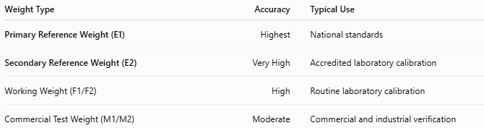
Weight Type | Accuracy | Typical Use
Primary Reference Weight (E1) | Highest | National standards
Secondary Reference Weight (E2) | Very High | Accredited laboratory calibration
Working Weight (F1/F2) | High | Routine laboratory calibration
Commercial Test Weight (M1/M2) | Moderate | Commercial and industrial verification

Care and Maintenance
# Source: AI Source: Provided by: [Data Path: Persons Table -> ID Column: 1, Name_En Column: Motasem Essam] -> From: [ChatGPT] on [7/17/2026]
To preserve accuracy:
- Store in a protective case.
- Handle only with gloves or tweezers.
- Avoid touching polished surfaces.
- Keep clean and dry.
- Recalibrate through an accredited laboratory at recommended intervals.

Common Mistakes
# Source: AI Source: Provided by: [Data Path: Persons Table -> ID Column: 1, Name_En Column: Motasem Essam] -> From: [ChatGPT] on [7/17/2026]
- Handling with bare hands.
- Mixing E2 weights with lower-class weights without proper procedures.
- Storing outside controlled environments.
- Using contaminated or damaged weights.

Key Points
# Source: AI Source: Provided by: [Data Path: Persons Table -> ID Column: 1, Name_En Column: Motasem Essam] -> From: [ChatGPT] on [7/17/2026]
- An E2 Secondary Reference Weight is calibrated against an E1 Primary Reference Weight.
- It is used to calibrate:
  - F1 working weights
  - Analytical balances
  - Lower-class calibration standards
- Available as:
  - Individual weights
  - Weight sets
  - Knob weights
  - Flat milligram weights
- Commonly used in accredited laboratories, pharmaceutical industries, research centers, and precision calibration facilities.

Conclusion
# Source: AI Source: Provided by: [Data Path: Persons Table -> ID Column: 1, Name_En Column: Motasem Essam] -> From: [ChatGPT] on [7/17/2026]
A Secondary Reference Weight (E2) is a high-precision calibration standard that serves as a critical link between Primary Reference Weights (E1) and routine working standards. Manufactured according to OIML R111 E2 specifications, these weights provide excellent accuracy and traceability, making them indispensable for analytical balance calibration, laboratory quality assurance, pharmaceutical production, scientific research, and accredited calibration services.

